OS LAB 09

TASK 1:

CODE:
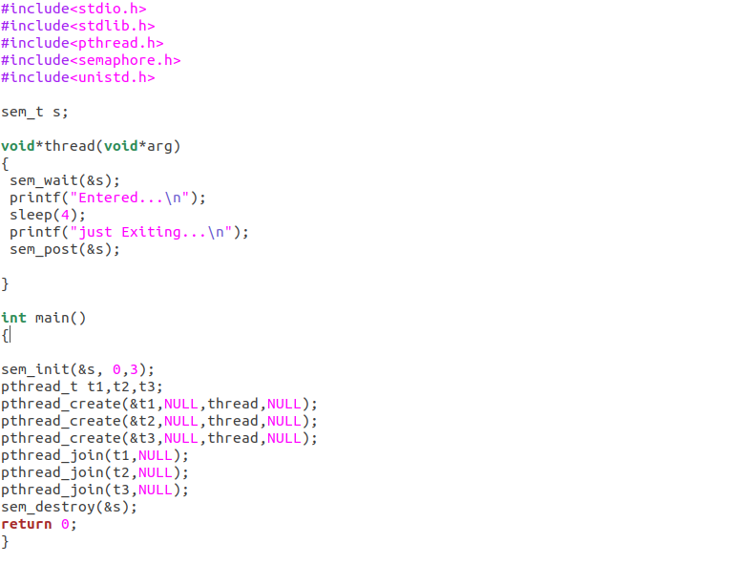
OUTPUT:

If s=1:

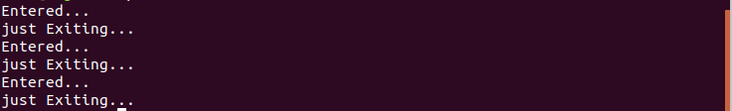

If s=5:

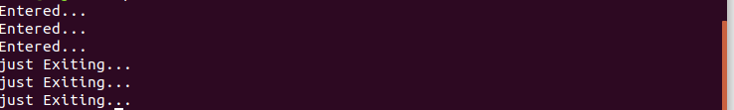
TASK 2:

CODE:

OUTPUT:

